**When do you get NaN as output :**

**Q) What will be the output of the below statement ? console.log(NaN == NaN)?**

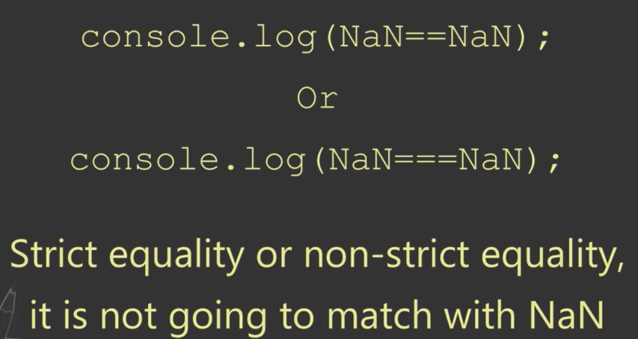 **returns false.**

**Q) What is the difference between isNaN() & isFinite() method?**

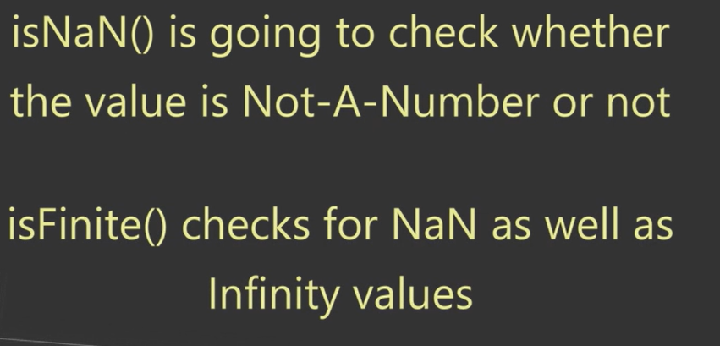

**Explain must know points of Arrow function :**

**Q) Explain the syntactical features of arrow function ?**

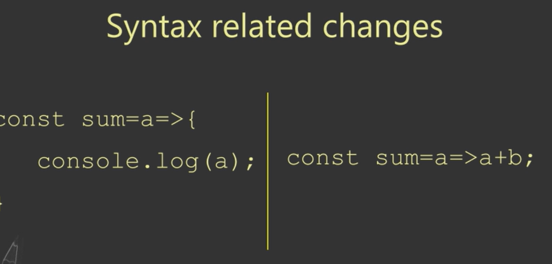

**Q) Why “this” does not work in arrow function?**



**Q) Explain output of the following code with a reason?**

**const obj = {**

**Method: () => {**

**Console.log(this);**

**}**

**}**

**Ans: window.**

**Q) How can you handle arguments object like functionality in arrow function?**

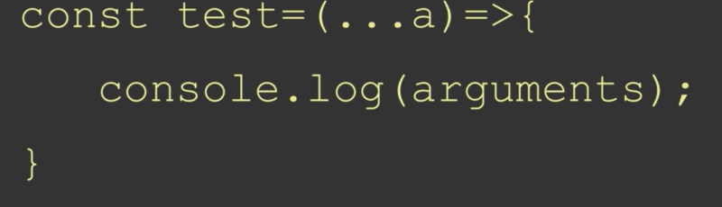

**Rest parameters**

**Q) Can you write IIFE with arrow function syntax?**

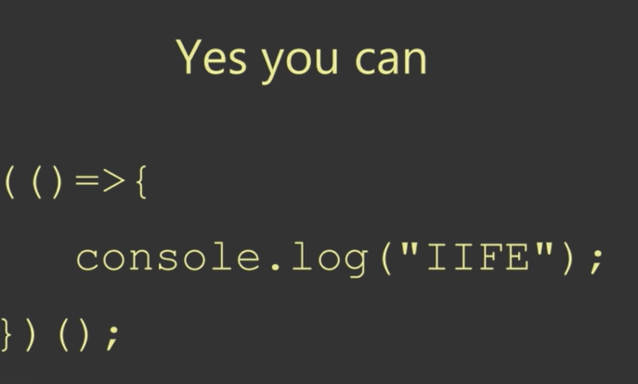

**How does a closure work in JS:**

**Q) How can you access private variable or a function outside the scope?**

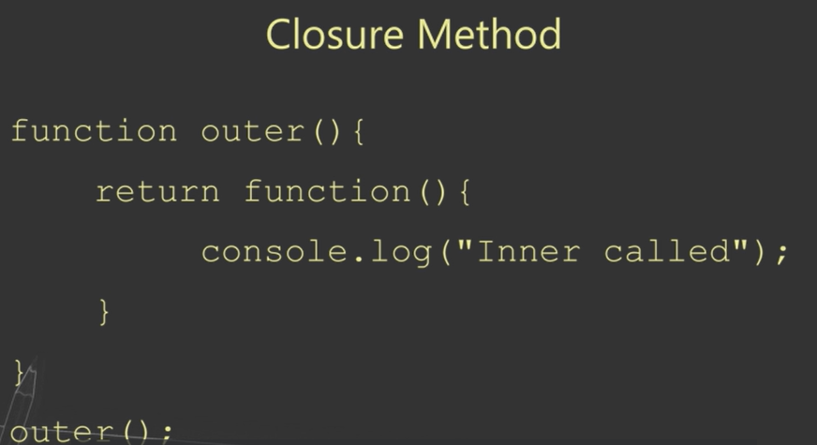

**Q) Explain the advantage of a closure?**



